Chapter 4, Solution 72.

- For the circuit in Fig. 4.138, obtain the Thevenin equivalent at terminals a-b.
- Calculate the current in R_{L} = 8Ω.
- Find R_{L} for maximum power deliverable to R_{L}.
- Determine that maximum power.

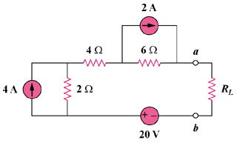

Figure 4.138
For Prob. 4.72.

Solution

(a) R_{Th} and V_{Th} are calculated using the circuits shown in Fig. (a) and (b) respectively.

From Fig. (a), R_{Th} = 2 + 4 + 6 = 12 ohms

From Fig. (b), -V_{Th} + 12 + 8 + 20 = 0, or V_{Th} = 40 V

6 Ω

2 Ω

(a)

R_{Th}

4 Ω

20V

+

V_{Th}

−

8V

+
−
− +
+ −

2 Ω

6 Ω

(b)

4 Ω

12V

(b) i = V_{Th}/(R_{Th} + R) = 40/(12 + 8) = 2A

(c) For maximum power transfer, R_{L} = R_{Th} = 12 ohms

(d) p = V_{Th}²/(4R_{Th}) = (40)²/(4x12) = 33.33 watts.

